**MACHINE LEARNING MINI PROJECT**

**INTRODUCTION:** A vertex in an undirected connected graph is an **articulation point** if removing it disconnects the graph. Articulation points represent vulnerabilities in a connected network – single points whose failure would split the network into disconnected components.

**PROBLEM STATEMENT:** “Given a dataset of a graph, consisting of vertices and edges, find the articulation points of the graph and plot the same.”

**DATASET:**

**Name of the dataset:** 9_11_edgelist.csv

**Description:** This dataset is a collection of nodes depicting a terrorist network. There are 69 vertices in the graph. There are 383 rows and 2 columns in the dataset. The dataset gives a “to” and “from” connection between the nodes.

**TECHNIQUES INVOLVED:**

* **Depth-first search:** DFS is an algorithm for traversing or searching tree or graph data structures. The algorithm starts at the root node and explores as far as possible along each branch before backtracking.
* **Data visualization:** It is the graphical representation of information and data.

**SOFTWARE REQUIREMENTS:** Python3, Libraries like pandas, network, numpy and matplotlib.

**CODE SNIPPETS:**

*BFS Implementation*

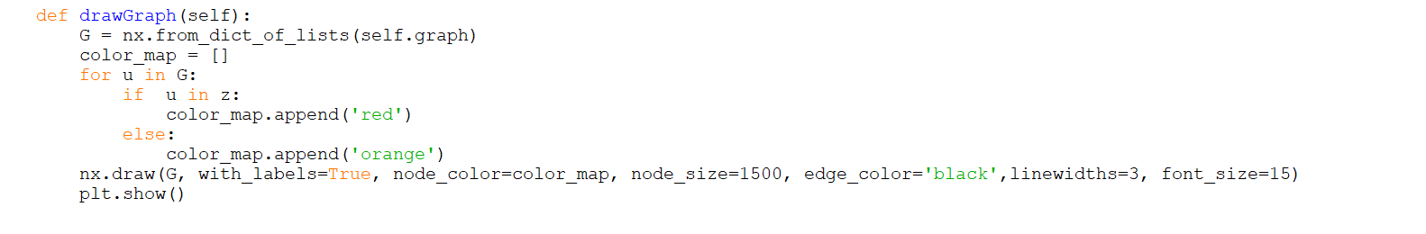

*Plotting the Graph*

**OUTPUT:**

*Console Output*

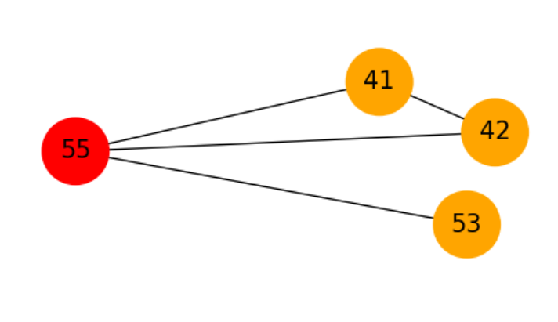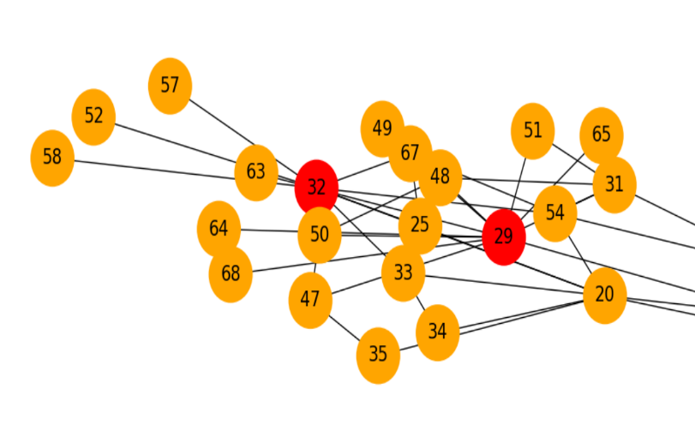

*Fig. 1 Fig. 2* **A close up of a logo

Description automatically generated**

*Fig. 3*

**TIME COMPLEXITY: O(V+E)**

**CONCLUSION:**

* Articulation points represent vulnerabilities in a connected network.
* They are useful for designing reliable networks.
* In the above example, if one can find the articulation points, one can decide which member to target to best disrupt the communication in the organisation.